

**USER**

**MANUAL**

**HomeSewa**

**HAHA MEMBERS:**

MUHAMMAD ASYRAF BIN OSMAN (2017155687)S

MUHAMMAD HAFIZ BIN MAZLAN (2017176145)

MUHAMMAD AMIRULLAH BIN RAMLI (2017696616)

MUHAMMAD HAMKA BIN ADNAN (2017360333)

M3CS251**4A |** Prepared for : **Mohd Ali Mohd Isa**

# PURPOSE OF THE DOCUMENT

The purpose of this document is as a guide for admin to handle this “HomeSewa” system. The main purpose of this system is to help the administrator to organize reservation of the property. This also will help the owner of the property to check the order for further action.

# Contents

1. PRESENTATION OF THE SOLUTION 4
   1. Project players 4
   2. Support 4
2. CONNECTING TO THE APPLICATION 5
   1. Address 5
   2. Authentication 5
3. STRUCTURING OF THE APPLICATION 7
   1. Layout 7
4. FUNCTIONALITIES 8
   1. Materials 8
   2. Reservation 9
   3. Property 10
   4. Customer 11
   5. Logout 12

## PRESENTATION OF THE SOLUTION

* 1. PROJECT PLAYERS
     + Admin : manage list of property.
  2. SUPPORT
     + E-mail : e-mail as a platform to recognize the admin



## CONNECTING TO THE APPLICATION

* 1. ADDRESS
     + You must connect to the application using the following address: http://127.0.0.1:8000/ (link is provided by the server)
  2. AUTHENTICATION
     + Admin need to log on into the system using their e-mail address and password by clicking on the “ADMIN” button at the Main page (*Figure 2.1*) of the system. After clicking, login boxes will appear at the bottom of the Main page (*Figure 2.2*)

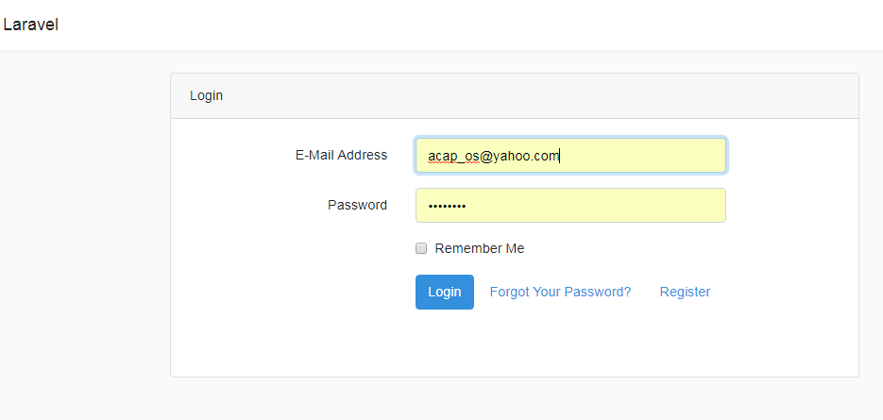

*Figure 2.1*

Step 1 : Key-in admin’s email address in the email address box. Step 2 : Key-in admin’s password in the password box.

Step 3 : Click on the “Login” to log into the system.

If the admin forget the password then click the link ‘Forgot Your Password?’ as shown in *Figure 2.2*

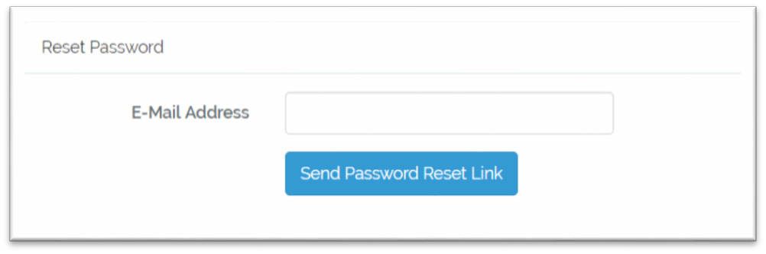

*Figure 2.2*

Notice that admin successful enter the system *when Figure 2.3* is appearing.

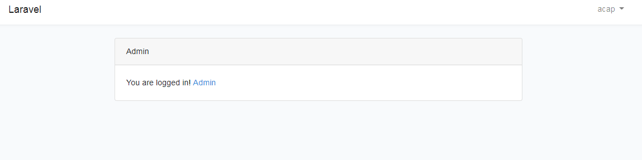

*Figure 2.3*

## STRUCTURING OF THE APPLICATION

* 2. LAYOUT

*Figure 3.1 preview the reservation list of property.* Admin can check the reservation from this page that made by customers.

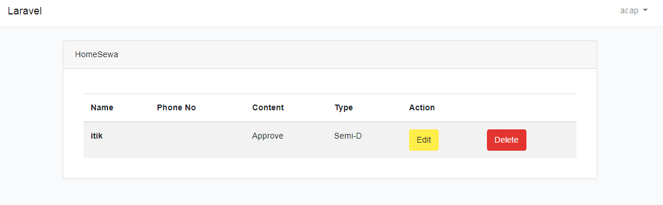

*Figure 3.1*

## FUNCTIONALITIES

Figure below show the content that can be edit by admin from the list of property

* + 1. 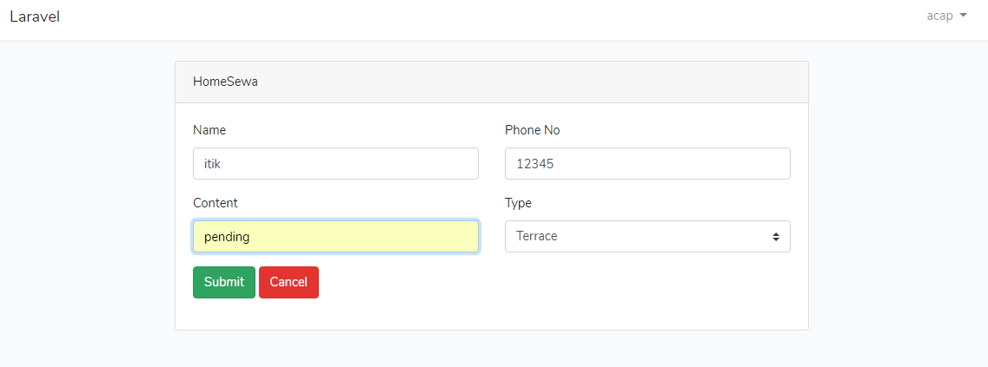

*Figure 4.1*

Set the name, phone number, type of property and content service condition of customer.

Edited content from reservation list of the property made by admin.

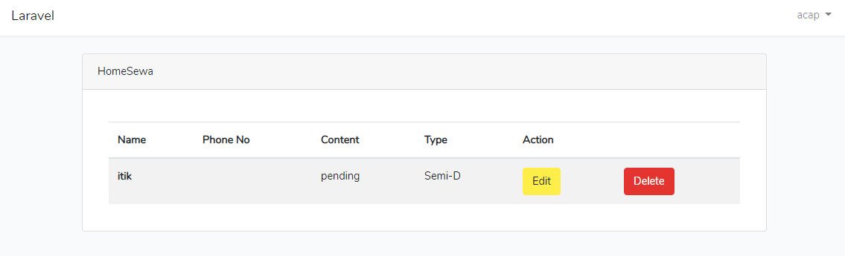

*Figure 4.2*

Delete reservation list of the property made by admin.

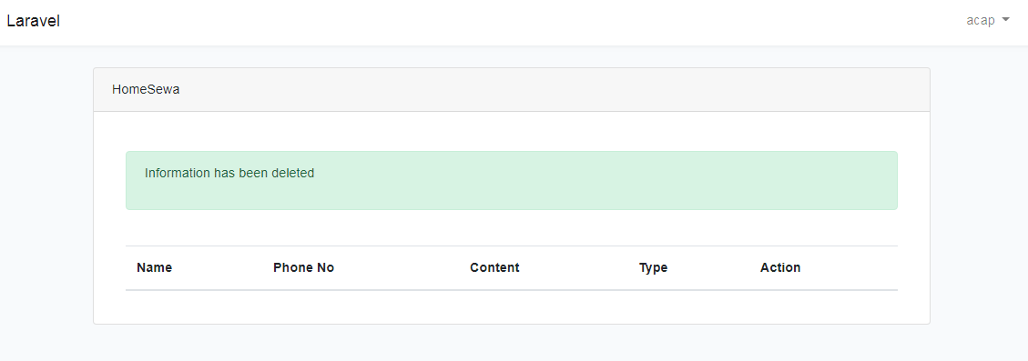

*Figure 4.3*

Add new property

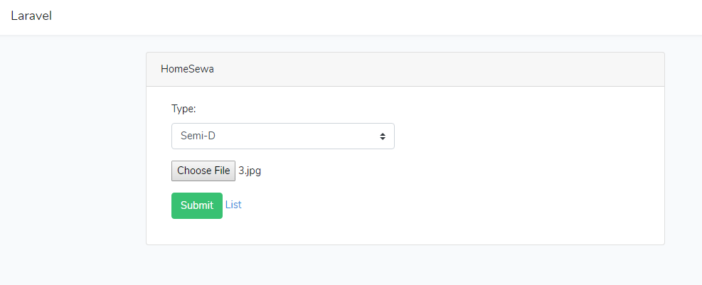

*Figure 4.4*

List of property

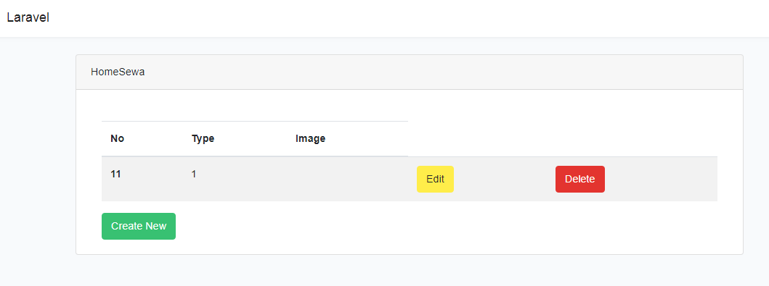

*Figure 4.5*

Delete property

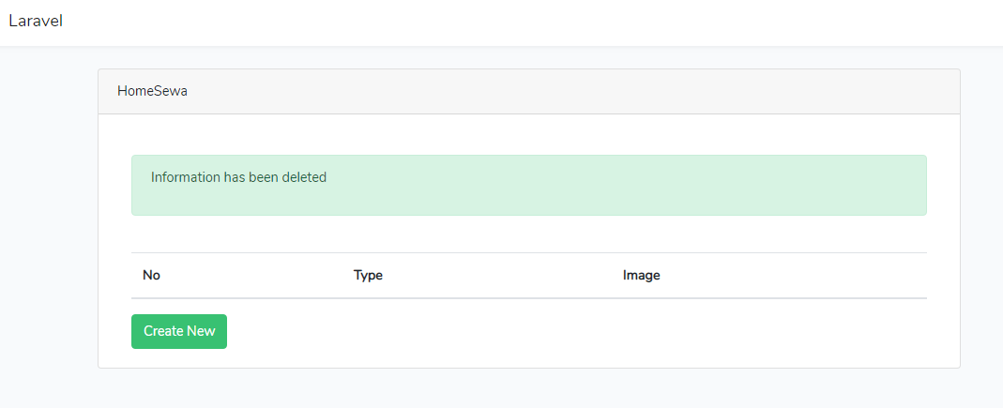

*Figure 4.6*

Add new customer details

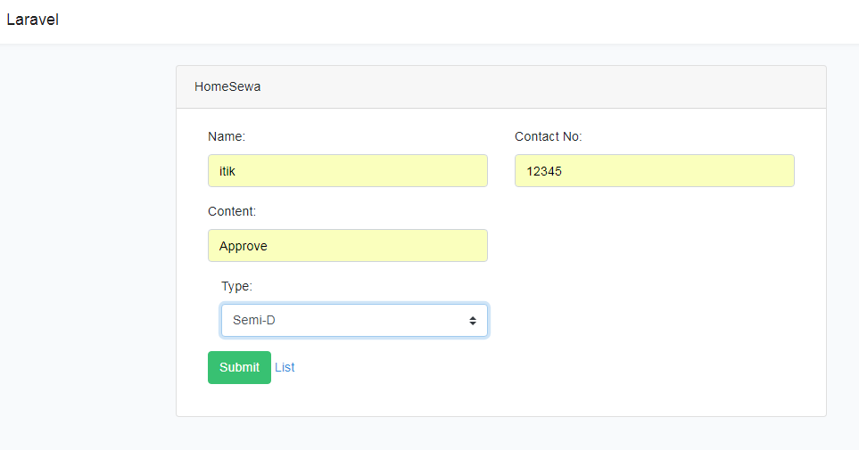

*Figure 4.7*

If the new added customer details is success then it will pop up *Figure 4.8*

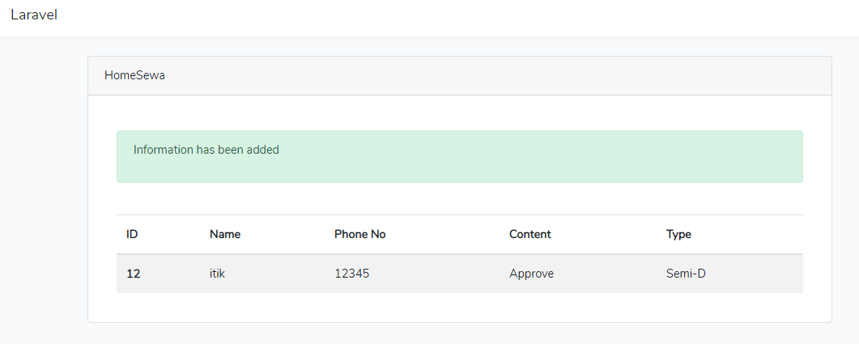

*Figure 4.8*

* 1. LOGOUT

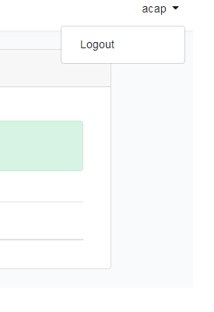

*Figure 5.1*

**- End of document -**